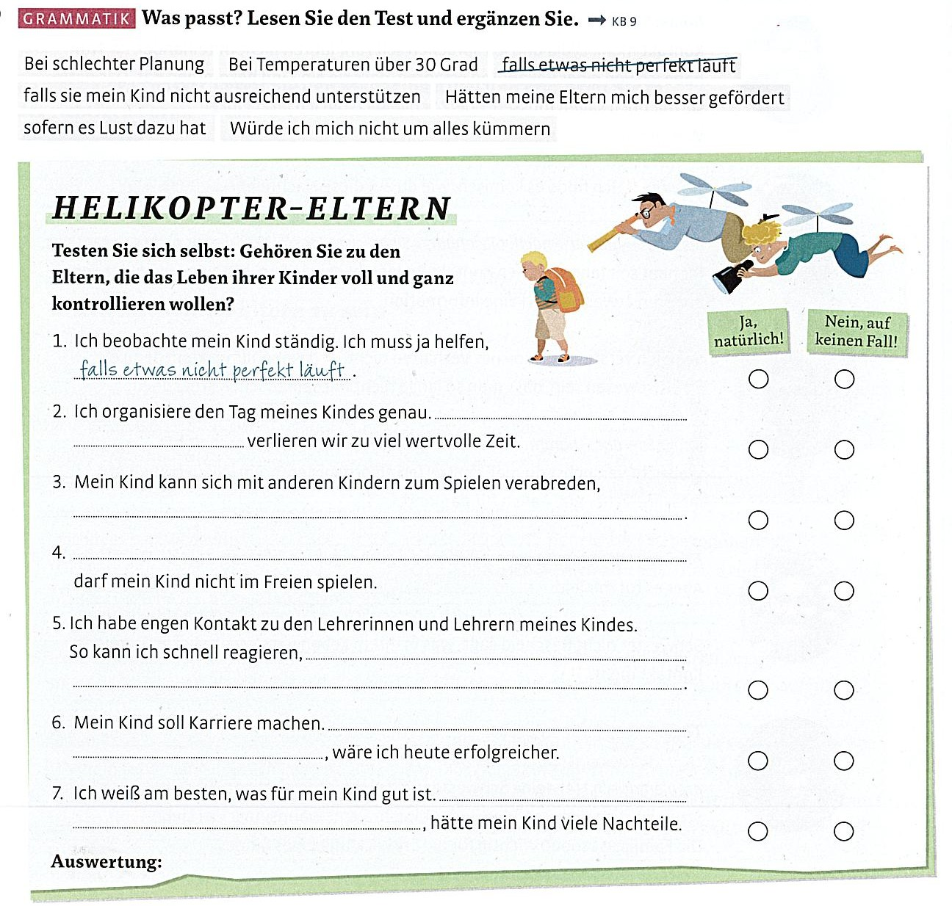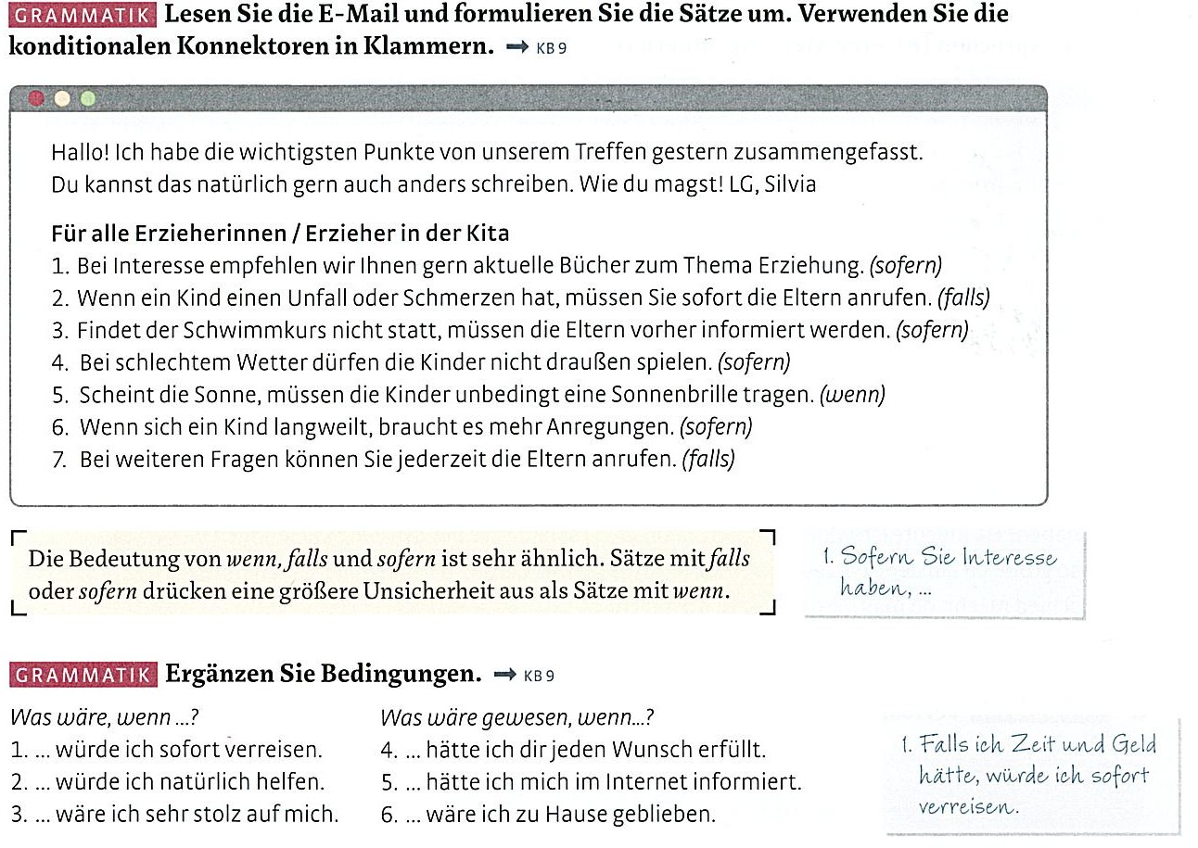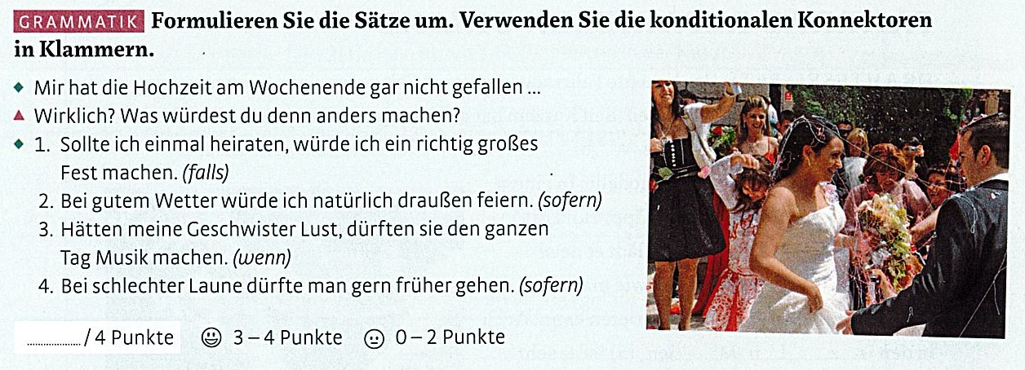
Schreiben Sie jetzt Ihre Sätze.
1. _______________________________________________________________________________
__________________________________________________________________________________

2. _______________________________________________________________________________
__________________________________________________________________________________

3. _______________________________________________________________________________
__________________________________________________________________________________

4. _______________________________________________________________________________
__________________________________________________________________________________

